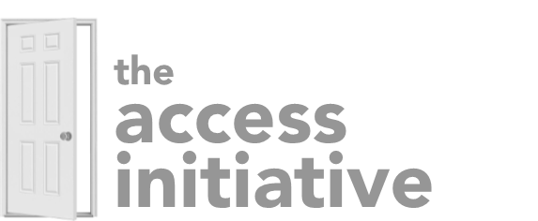
Central District of the C&MA
Memorandum of Understanding

Name of Church Involved: Click or tap here to enter text.

Name of Project: Click or tap here to enter text.

Category of Request
☐ A. Investment in Special Opportunities
☐ B. Investment in Ongoing Support
☐ C. Investment in Leadership Discovery/Development/Deployment
☐ D. Investment in the Next Generation

Duration of Investment: Click or tap here to enter text.

Is your church seeking to designate .5% of District Advance giving to this project?
☐Yes or ☐ No

Date of Review of MOU: Click or tap here to enter text.
Electronic Signature of Party #1 : Click or tap here to enter text.
Electronic Signature of Party #2 : Click or tap here to enter text.
______________________________________________________________________________
For office use only:
Date Received: Click or tap here to enter text.
Date Approved: Click or tap here to enter text.
Review Date: Click or tap here to enter text.

